**A**

**MINI PROJECT REPORT**

**ON**

# “DAIRY MANAGEMENT SYSTEM”

**SUBMITTED TO**

**SHIVAJI UNIVERSITY, KOLHAPUR**

**IN THE PARTIAL FULFILLMENT OF THE REQUIREMENT**

**FOR THE AWARD OF DEGREE**

**BACHELOR OF TECHNOLOGY IN COMPUTER SCIENCE AND**

**ENGINEERING (AI&DS)**

**SUBMITTED BY**

|  |  |  |
| --- | --- | --- |
| **MS. MAHI SACHIN PARMAR** |  | **23UAD305** |
| **MR. SHAHURAJE BAJIRAO PATIL** |  | **23UAD307** |
| **MR. VALLABH VINAYAK SANGAR** |  | **23UAD308** |

**UNDER THE GUIDANCE OF**

**Dr. P. S. More**



**DEPARTMENT OF COMPUTER SCIENCE AND ENGINEERING (AI&DS)**

**DKTE SOCIETY’S TEXTILE AND ENGINEERING** **INSTITUTE, ICHALKARANJI**

**(AN AUTONOUMOUS INSTITUTE)**

## 2024-2025



**CERTIFICATE**

**This is to certify that, project work entitled**

# “DAIRY MANAGEMENT SYSTEM”

**is a bonafide record of project work carried out in this college by**

|  |  |  |
| --- | --- | --- |
| **MS. MAHI SACHIN PARMAR** |  | **23UAD305** |
| **MR. SHAHURAJE BAJIRAO PATIL** |  | **23UAD307** |
| **MR. VALLABH VINAYAK SANGAR** |  | **23UAD308** |

**is in the partial fulfillment of award of degree Bachelor of Technology in Computer Science & Engineering (AI&DS) prescribed by Shivaji University, Kolhapur for the academic year 2024-2025.**

**Dr. P. S. More**

**Project Guide**

**Prof. Dr. T.I.BAGBAN Prof. Dr. L.S. Admuthe**

**HOD OF AI&DS Dept. Director**

**Examiner: ________________**

# DECLARATION

We hereby declare that, the project work report entitled “Dairy Management System” which is being submitted to D.K.T.E. Society’s Textile and Engineering Institute Ichalkaranji, affiliated to Shivaji University, Kolhapur is in partial fulfillment of degree B.Tech.(CSE AI&DS). It is a bonafide report of the work carried out by us. The material contained in this report has not been submitted to any university or institution for the award of any degree. Further, we declare that we have not violated any of the provisions under Copyright and Piracy / Cyber / IPR Act amended from time to time.

|  |  |  |
| --- | --- | --- |
| **MS. MAHI SACHIN PARMAR** |  | **23UAD305** |
| **MR. SHAHURAJE BAJIRAO PATIL** |  | **23UAD307** |
| **MR. VALLABH VINAYAK SANGAR** |  | **23UAD308** |

# ACKNOWLEDGEMENT

With great pleasure we wish to express our deep sense of gratitude to Dr. P . S. More for his valuable guidance, support, and encouragement in the completion of this project report.

Also, we would like to take the opportunity to thank our head of department Dr.T.I.BAGBAN for his cooperation in preparing this project report.

We feel gratified to record our cordial thanks to other staff members of the Computer Science and Engineering Department (AI&DS) for their support, help, and assistance which they extended as and when required.

Thank you,

|  |  |  |
| --- | --- | --- |
| **MS. MAHI SACHIN PARMAR** |  | **23UAD305** |
| **MR. SHAHURAJE BAJIRAO PATIL** |  | **23UAD307** |
| **MR. VALLABH VINAYAK SANGAR** |  | **23UAD308** |

**INDEX**

**CONTENTS PAGE**

1. Abstract 7
2. Problem Statement 7
3. Problem Description 7
4. Introduction 8
5. Implementation 9
6. Requirement Analysis 11

Functional Requirement

Non-Functional Requirements

User Requirement

Technical Requirement

1. System Requirements 14

Software Requirements

Hardware Requirements

1. System Design 16

System Architecture Diagram

Use case Diagram

Sequence Diagram

Data Flow Diagram

1. Testing Table 18
2. Snapshot 19
3. Applications 21
4. Future Scope 23
5. Conclusion 25
6. References 25

## **Abstract**

**Title** : DAIRY MANAGEMENT SYSTEM

The Dairy Management System (DMS) is an innovative software solution designed to enhance the operational efficiency of dairy farms. This application facilitates the registration of new members, allows for the tracking of dairy physical records, and provides an admin interface for managing registered users. The system includes a collection panel to manage milk collection based on cow and buffalo categories, with specific time slots for morning and evening collections. Additionally, it enables the updating of dairy rates based on Solid-Not-Fat (SNF) and Fat content, and provides visual charts for rate analysis. The DMS also manages sales records according to time slots, generates bills for collection members, and allows for bill tracking and saving as PDFs. This project aims to streamline dairy management processes, improve record accuracy, and enhance user experience.

## **Problem Statement**

**Problem Statement**

The Dairy Management System addresses several key challenges faced by dairy farms:

1. **Data Inaccuracy**: Manual record-keeping can lead to errors in tracking milk production and inventory.
2. **Inefficiency**: Traditional methods of managing dairy operations are labor-intensive and time-consuming.
3. **Limited Accessibility**: Farmers often lack real-time access to critical data regarding milk production and inventory levels.
4. **Poor Communication**: Ineffective communication between dairy management and collection members can lead to misunderstandings and delays.
5. **Lack of Reporting Tools**: Without proper reporting mechanisms, it is challenging to make informed decisions based on production and sales data.

## **Problem Description**

Current dairy management practices often rely on manual tracking, which can lead to errors, inefficiencies, and challenges in maintaining accurate records. The DMS aims to address these issues by automating and centralizing dairy operations.

**Introduction**

The Dairy Management System (DMS) is a comprehensive software application designed to automate and streamline the various processes involved in managing dairy operations. As dairy farming becomes increasingly complex, the need for an efficient system that enhances productivity and data accuracy is paramount. The DMS provides a centralized platform for managing milk collection, inventory, sales, and member records, ultimately aiming to improve operational efficiency and profitability.

**Aim and Objectives**

**Aim**: To develop a user-friendly Dairy Management System that automates dairy operations, enhances record accuracy, and improves communication among stakeholders.

**Objectives**:

1. **Member Registration**: To facilitate the easy registration of new members into the system.
2. **Record Management**: To provide tools for tracking dairy physical records efficiently.
3. **Milk Collection Management**: To enable collection based on cow and buffalo categories with defined time slots.
4. **Rate Management**: To allow for the updating of dairy rates based on SNF and Fat content.
5. **Sales Management**: To manage sales records according to time slots and generate bills for collection members.
6. **Reporting**: To provide visual charts for analyzing rates and tracking bills.

**Implementation**

**Functional Requirements**:

* **User Authentication**: Secure login for administrators and collection members.
* **Member Management**: Ability to register, view, and manage member records.
* **Milk Collection**: Functionality to log milk collection based on categories and time slots.
* **Rate Management**: Tools to update and display dairy rates based on SNF and Fat.
* **Bill Generation**: Automated bill generation for collection members, with options to save as PDF.

**Non-Functional Requirements**:

* **Usability**: An intuitive interface for easy navigation.
* **Performance**: The system should handle multiple users without degradation.
* **Security**: Implementation of data encryption and secure access protocols.

**Technical Requirements**:

* **Hardware**: Server specifications to host the application with adequate storage and processing power.
* **Software**: MySQL for data storage and Java for application development.

**System Design**

* **Architecture**: The system follows a client-server architecture where the client interface is developed using JavaFX, and the backend is managed using Java with MySQL database integration.
* **Use Case Diagram**: Illustrates the interactions between users and the system functionalities.
* **Data Flow Diagram (DFD)**: Represents the flow of data within the system, highlighting key processes such as member registration and milk collection.

**Testing**

* **Unit Testing**: Each module was tested independently to ensure functionality.
* **Integration Testing**: Confirmed that all modules work together seamlessly.
* **User Acceptance Testing (UAT)**: Involved end-users to gather feedback and make necessary adjustments.

**Conclusion**

The Dairy Management System effectively addresses the operational challenges faced by dairy farms. By automating key processes and providing a user-friendly interface, the DMS enhances data accuracy, improves communication, and supports informed decision-making. As the dairy industry continues to evolve, the integration of technology through systems like the DMS will be essential for maintaining competitiveness and sustainability.

**Requirement Analysis**

Requirement analysis is a crucial phase in the development of the Dairy Management System (DMS) as it helps identify and document the needs and expectations of stakeholders. This process ensures that the final system effectively meets the requirements. Below is a breakdown of the requirement analysis for the DMS based on the functionalities previously discussed.

**1. Stakeholder Identification**

* **Farmers**: Need access to milk production records, member registration, and inventory management.
* **Collection Members**: Require tools for logging milk collection and viewing their bills.
* **Administrators**: Need oversight of the entire system, including user management, data security, and reporting functionalities.
* **Customers**: May require access to billing information and payment history.

**2. Functional Requirements**

* **User Authentication**:
  + Ensure secure login for administrators, farmers, and collection members with role-based access control.
* **Member Registration**:
  + Functionality to register new members into the system, including personal and contact information.
* **Dairy Record Management**:
  + Tools for tracking dairy physical records, including cow and buffalo categories.
* **Milk Collection Management**:
  + Ability to log milk collection based on categories (cow and buffalo) and time slots (morning and evening).
* **Rate Management**:
  + Functionality to update dairy rates based on Solid-Not-Fat (SNF) and Fat content.
* **Sales Management**:
  + Manage sales records according to time slots and generate bills for collection members.
* **Reporting**:
  + Generate visual charts for rate analysis and track bills, with options to save reports as PDFs.
* **Notification System**:
  + Automated notifications for collection members regarding their billing and updates on rates.

**3. Non-Functional Requirements**

* **Usability**:
  + The interface should be intuitive and easy to navigate for all user types, requiring minimal training.
* **Performance**:
  + The system should support multiple users simultaneously without significant delays.
* **Security**:
  + Implement data encryption and secure access protocols to protect sensitive information.
* **Scalability**:
  + The system should be designed to handle an increasing number of users and data volume as the dairy operations grow.
* **Reliability**:
  + Ensure high availability and minimal downtime for maintenance to provide continuous access to the system.

**4. Technical Requirements**

* **Hardware**:
  + Specify server requirements for hosting the application, including sufficient storage and processing power.
* **Software**:
  + Identify the software stack, including programming languages (Java), frameworks (JavaFX), and database management systems (MySQL).
* **Integration**:
  + Requirements for integrating with other systems, such as accounting software or inventory management systems.

**5. User Requirements**

* **Training and Support**:
  + Provision of training sessions and materials for users to familiarize themselves with the system.
* **Feedback Mechanism**:
  + Establish a process for users to provide feedback on system functionality and report issues for continuous improvement.

**6. Data Requirements**

* **Data Input**:
  + Define the types of data to be collected, including member information, milk collection records, and billing details.
* **Data Storage**:
  + Requirements for data storage solutions, including database design considerations for efficient data retrieval.
* **Data Privacy**:
  + Compliance with data protection regulations to ensure that sensitive information is handled appropriately.

## **System Requirements**

The system requirements outline the necessary hardware and software specifications needed to effectively run the Dairy Management System (DMS). This ensures that the application operates smoothly and efficiently.

**1. Hardware Requirements**

**Server Specifications**:

* **Processor**: Multi-core processor (e.g., Intel Xeon or equivalent) with a minimum of 2.0 GHz.
* **RAM**: At least 16 GB of RAM (expandable based on user load).
* **Storage**:
  + Minimum of 500 GB SSD for fast data access.
  + Additional backup storage (e.g., 1 TB HDD) for redundancy and data safety.
* **Backup**: External backup solution or cloud storage for data redundancy.

**Client Machines**:

* **Processor**: Dual-core processor or better.
* **RAM**: Minimum of 4 GB RAM.
* **Storage**: 250 GB HDD or SSD.
* **Display**: Minimum 15-inch monitor with a resolution of 1024 x 768.

**2. Software Requirements**

**Operating System**:

* **Server**:
  + Windows Server

**Client**:

* + Windows 10 or later, or

**Database Management System**:

* MySQL (recommended) for data storage and management.

**Web Application Framework**:

* Java-based frameworks (e.g., Spring, JavaFX) for building the application.

**Web Server**:

* Apache Tomcat or any compatible server for hosting Java applications.

**Programming Languages**:

* **Frontend**: JavaFX for user interface development.
* **Backend**: Java for application logic.

**3. Additional Requirements**

* **Network**: Reliable internet connectivity for cloud-based solutions or a local network for on-premise installations.
* **Development Tools**: IDEs such as IntelliJ IDEA or Eclipse for Java development.
* **Version Control**: Git for managing code versions and collaboration among developers.

**Conclusion**

The system requirements for the Dairy Management System are designed to ensure optimal performance and reliability. By adhering to these specifications, the DMS can provide efficient management of dairy operations, including member registration, milk collection, and billing processes. Proper hardware and software configurations will enhance user experience and system stability.

**System Design**

1. System Architecture Diagram:

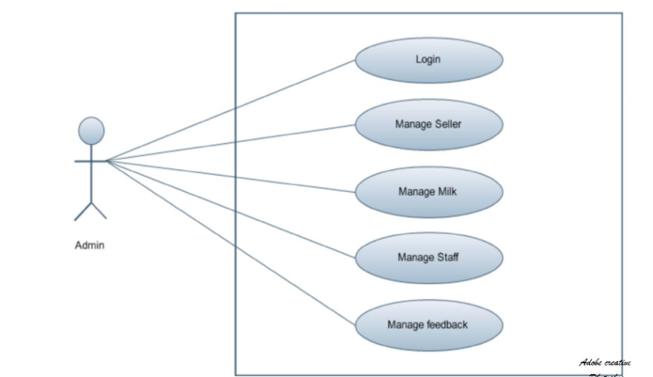

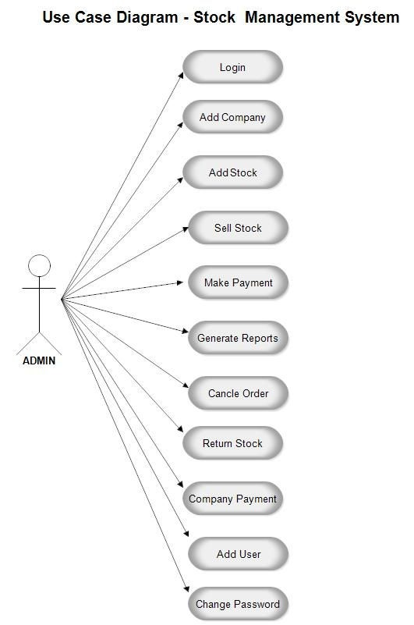

1. Use case Diagram:

C]Sequence Diagram:

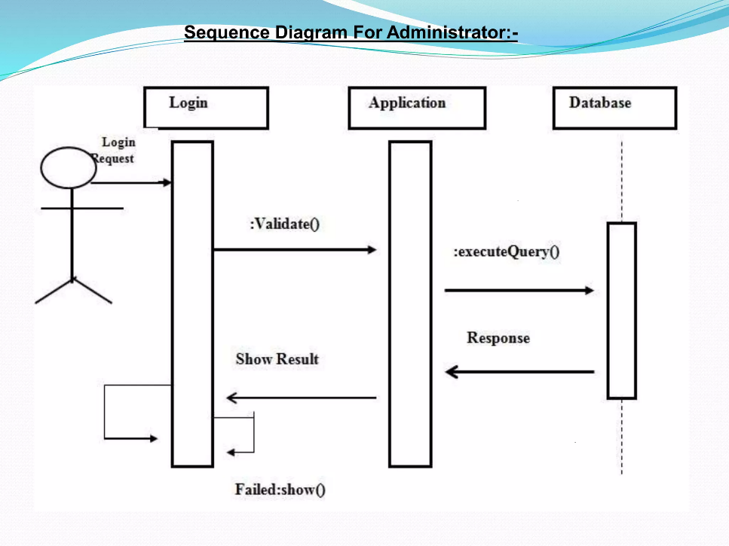

D] DFD Diagram:

Level 0:

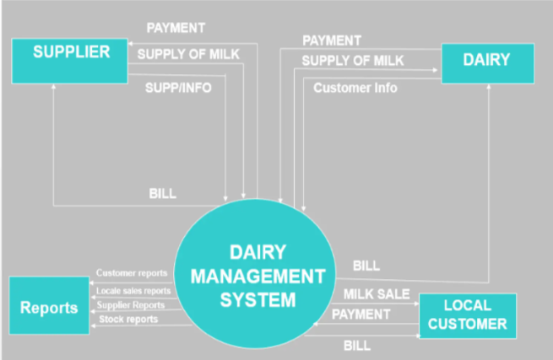

Level 1:

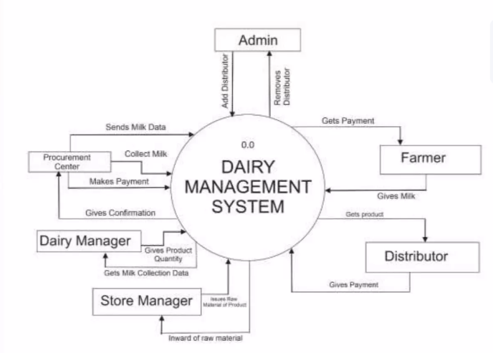

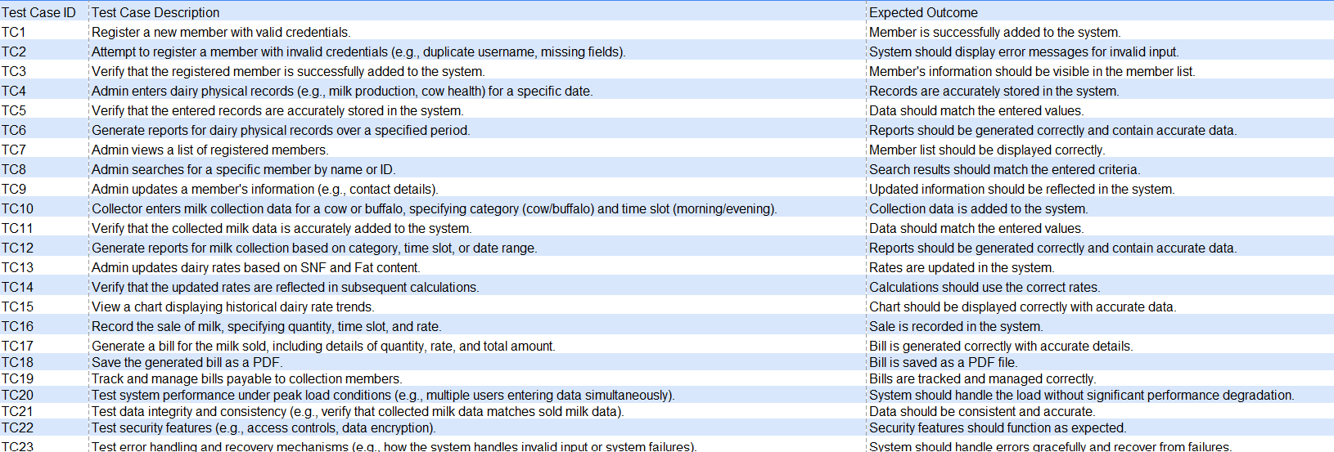 **TESTING TABLE**

**Snapshots**

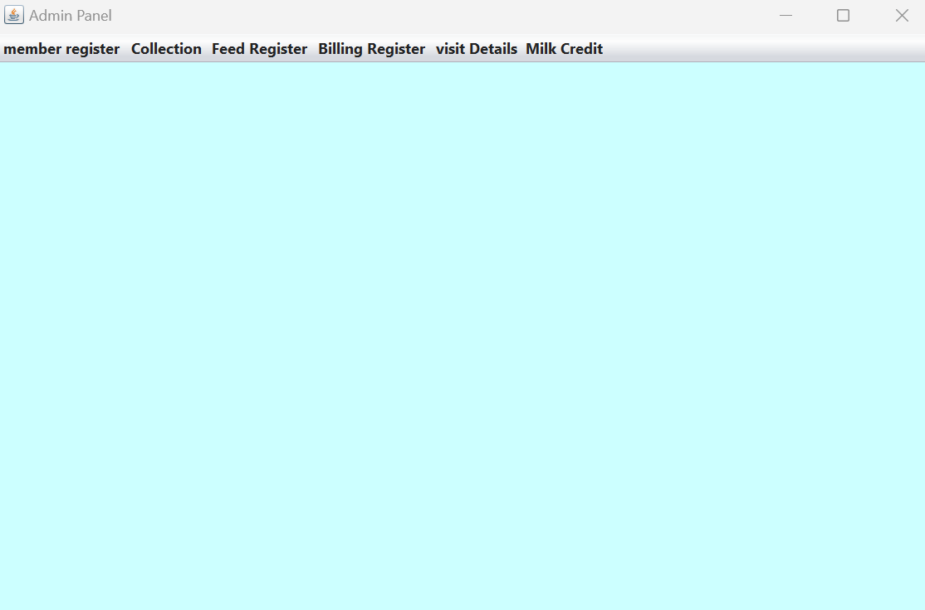**MAIN PAGE:**

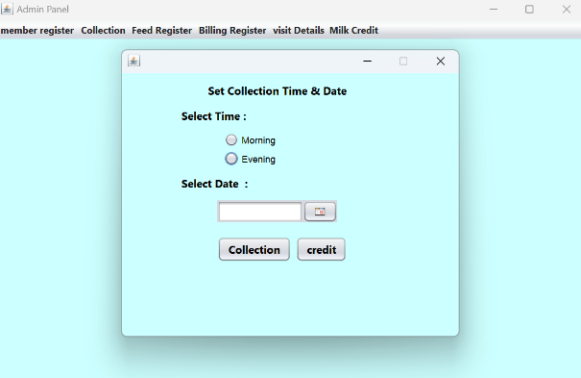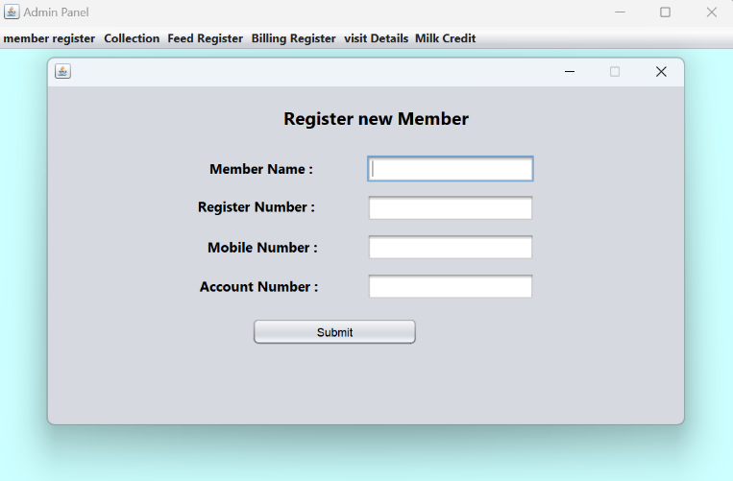**REGISTRATION:**

**SET RATE:**

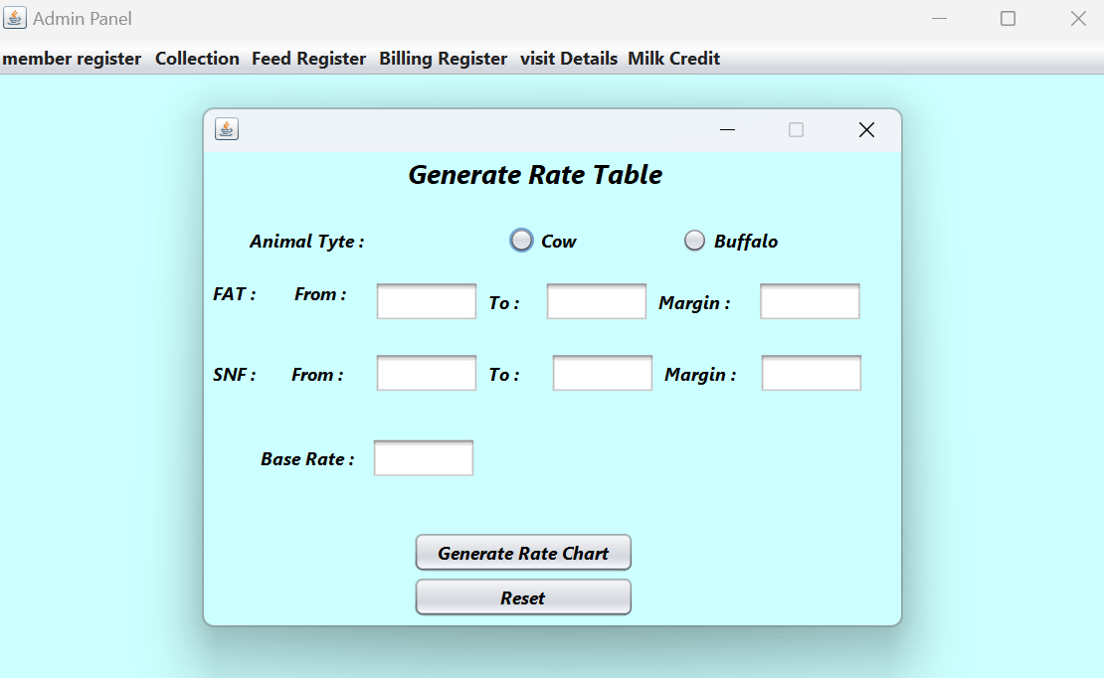

**GENERATE RATE :**

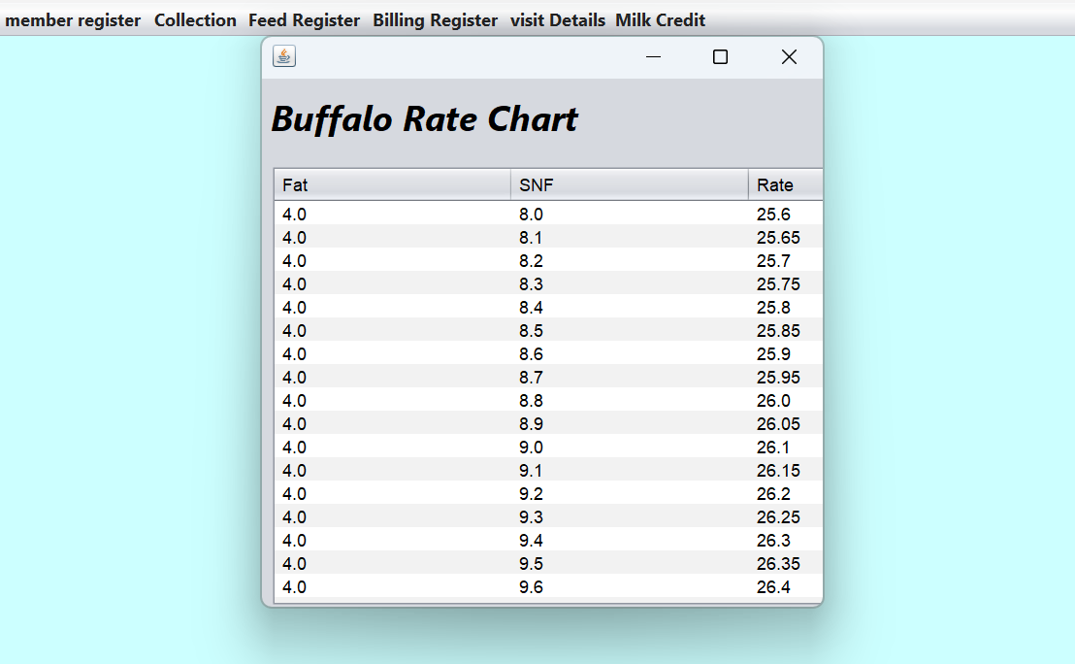**RATE CHARTS:**

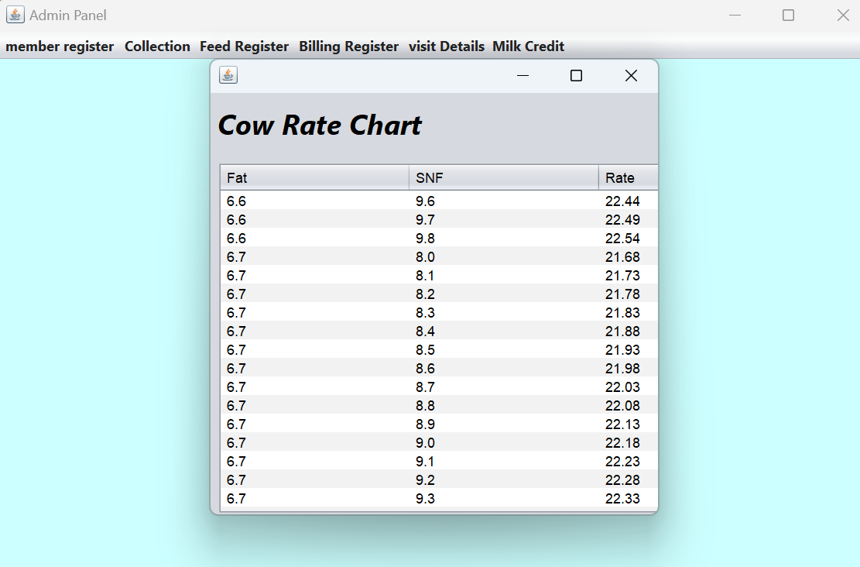

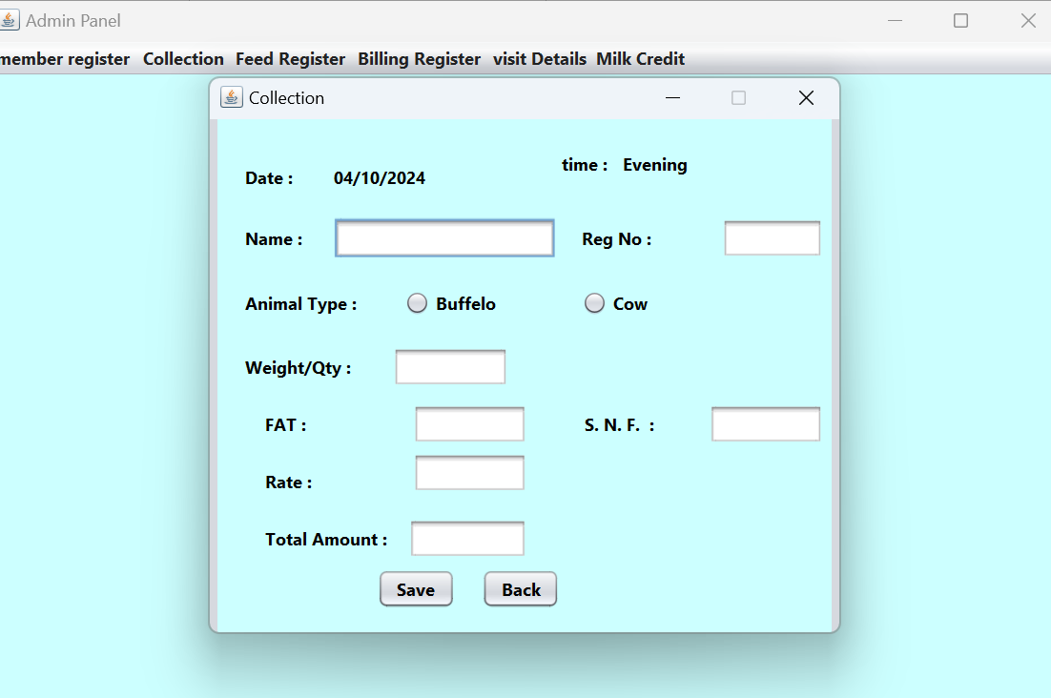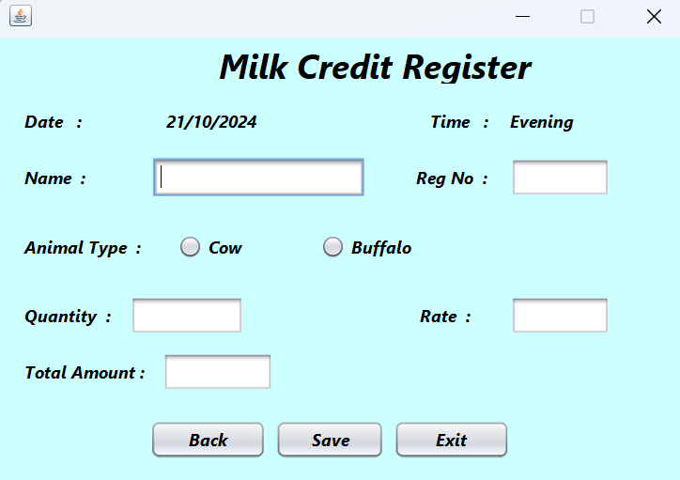**MILK CREDIT:** **MILK COLLECTION :**

**Applications**

A Dairy Management System (DMS) can significantly enhance the efficiency and effectiveness of dairy operations. Based on the functionalities you provided, here are the key applications of the DMS:

**1. Member Registration**

* Functionality: Allows new members (farmers, collection agents) to register in the system.
* Benefits:
  + Streamlined onboarding process.
  + Centralized database of registered members.

**2.** **Admin Management**

* Functionality: Admins can view and manage registered users and track physical records.
* Benefits:
  + Improved oversight of member activities.
  + Easier management of user data and permissions.

**3. Milk Collection Management**

* Functionality: Facilitates the collection of milk based on categories (e.g., cow and buffalo) during designated time slots (morning and evening).
* Benefits:
  + Enhanced organization of milk collection.
  + Better tracking of milk sources and quality.

**4. Rate Management**

* Functionality: Updates dairy rates based on Solid-Not-Fat (SNF) and Fat content.
* Benefits:
  + Accurate pricing based on milk quality.
  + Flexibility to adjust rates based on market conditions.

**5. Billing Management**

* Functionality: Generates bills for collection members based on milk collected and tracks payments.
* Benefits:
  + Transparency in transactions.
  + Efficient billing process.

**6. Reporting and Analytics**

* Functionality: Provides visual charts and reports for rates and milk collection data.
* Benefits:
  + Data-driven decision-making.
  + Insights into operational trends and performance.

**7. Document Management**

* Functionality: Allows tracking and saving bills as PDFs for record-keeping.
* Benefits:
  + Easy access to financial documents.
  + Enhanced accountability and audit readiness.

**8. User -Friendly Interface**

* Functionality: A well-designed interface for both admins and users.
* Benefits:
  + Improved user experience.
  + Reduced training time for new users.

**Future Scope**

The Dairy Management System (DMS) has significant potential for growth and enhancement. Below are some areas where the system can evolve and expand its functionalities:

**1. Mobile Application Development**

* Description: Create a mobile app for farmers and collection agents.
* Benefits:
  + Accessibility on-the-go.
  + Real-time updates and notifications.

**2. Integration with IoT Devices**

* Description: Use Internet of Things (IoT) sensors for monitoring milk quality, cow health, and environmental conditions.
* Benefits:
  + Enhanced data collection for better decision-making.
  + Improved animal welfare and milk quality control.

**3. Advanced Analytics and AI**

* Description: Implement machine learning algorithms for predictive analytics.
* Benefits:
  + Forecasting milk production and demand.
  + Optimizing pricing strategies based on historical data.

**4. Blockchain for Transparency**

* Description: Utilize blockchain technology for secure and transparent transactions.
* Benefits:
  + Enhanced traceability of milk from farm to consumer.
  + Increased trust among stakeholders.

**5. Enhanced Reporting Features**

* Description: Develop more advanced reporting tools with customizable dashboards.
* Benefits:
  + Better visualization of data.
  + Tailored insights for different user roles.

**6. User Training and Support**

* Description: Establish training programs and support systems for users.
* Benefits:
  + Increased user adoption and satisfaction.
  + Reduced operational errors.

**7. Collaboration with Supply Chain Partners**

* Description: Integrate with suppliers, distributors, and retailers.
* Benefits:
  + Streamlined supply chain operations.
  + Improved inventory management and logistics.

**8. Sustainability Features**

* Description: Implement features that promote sustainable farming practices.
* Benefits:
  + Reduced environmental impact.
  + Compliance with regulations and certifications.

**9. Multi-language Support**

* Description: Offer the system in multiple languages to cater to diverse user bases.
* Benefits:
  + Increased accessibility for non-native speakers.
  + Broader market reach.

**10. Feedback and Improvement Mechanism**

* Description: Establish a system for user feedback and continuous improvement.
* Benefits:
  + Adaptation to user needs and preferences.
  + Continuous enhancement of system functionalities.

**Conclusion**

The developed Dairy Management System (DMS) effectively addresses the needs of dairy farms by providing comprehensive features for managing various aspects of dairy operations. The system enables member registration, dairy physical record tracking, registered user management, milk collection, dairy rate management, and milk selling and billing.

**Key functionalities and benefits include:**

* **Centralized data management:** The DMS centralizes dairy-related information, improving data accuracy and accessibility.
* **Enhanced efficiency:** Automation of tasks such as milk collection and billing streamlines operations and reduces manual effort.
* **Improved decision-making:** The system provides valuable insights through reports and analytics, enabling informed decision-making for dairy farm management.
* **Scalability:** The DMS can accommodate the growth of dairy operations by handling increasing volumes of data and transactions.
* **Cost-effectiveness:** By automating processes and reducing manual errors, the DMS can contribute to cost savings.

## **References**

1.<https://www.google.com>

2. <https://chatgpt.com>

3. <https://www.youtube.com/>